To make an RDP connection to a 2012 server, click the add button from the connections manager and choose RDesktop.
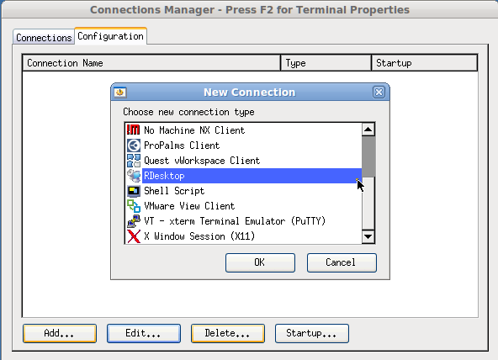
Enter your server’s name or IP address and, you must check the NLA (Network Level Authentication) box in order to connect to a 2012 server.
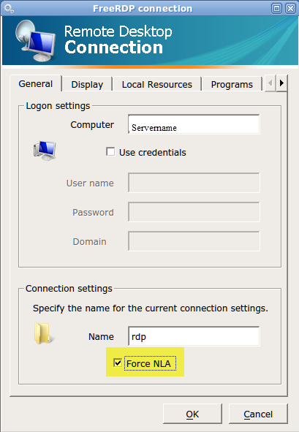
You can choose to save credentials or leave this blank and the user will be prompted for their credentials. For name, choose a name for your connection, click Ok and you can now connect your thin client to a Windows 2012 server RDP session.

